Ped1: Neonatal Herpes Simplex Virus Infection
HISTORY
A 6-day-old girl is brought to clinic by her mother for a 6-hour history of irritability, decreased oral intake, and fever of 100.4°F (38°C). She was delivered vaginally at 39-weeks gestation to a gravida 2, para 1 woman after an uncomplicated pregnancy with routine prenatal care. The mother denies any past medical history, illness, or infections during pregnancy; her only medication was prenatal vitamin. On examination, the infant has a temperature of 100.2°F (37.9°C), heart rate 145 beats/min, respiratory rate 64 breaths/min, and she is fussy with any movement despite being swaddled.

PHYSICAL EXAMINATION
The only findings on physical examination are about 10 small 2-mm, fluid-filled lesions surrounded by an erythematous base on her right shoulder (Figure 6–1).
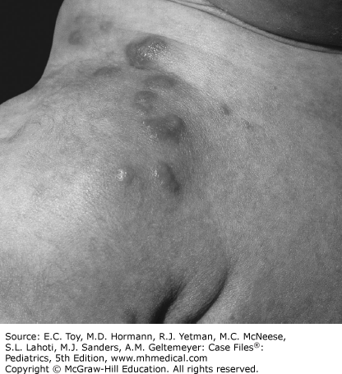

Citation: Toy, Eugene C. Case Files: Pediatrics. 5th ed. New York, N.Y.: McGraw-Hill Education LLC., 2016.

Ped2: Pneumonia

HISTORY
A 4-year-old boy has a 2-day history of runny nose, productive cough, and wheezing. Subjective fever and decreased appetite also were noted today. He has no known cardiorespiratory disease, and his immunizations are current. His two younger siblings are recovering from “chest colds.”

PHYSICAL EXAMINATION
On examination, he is febrile to 103.2°F (39.6°C), with a respiratory rate of 22 breaths/min. His examination is remarkable for congested nares, clear runny nose, coarse breaths sounds in all lung fields, and bibasilar end-expiratory wheezes.

Citation: Toy, Eugene C. Case Files: Pediatrics. 5th ed. New York, N.Y.: McGraw-Hill Education LLC., 2016.

Ped3: Acute Otitis Media

HISTORY
A 4-year-old child is seen by the clinician for ear pain. His mother reports he was in his usual state of good health until about 5 days ago when he developed an upper respiratory infection (URI) consisting of clear nasal discharge and cough. He had been having normal activity and intake until about 48 hours prior when he developed a temperature of 102.1°F (38.9°C) and complaints that his left ear hurts. She denies nausea, vomiting, diarrhea, headache, or change in urine output. She reports that he did not sleep well the previous evening, awakening several times complaining of ear pain, but remains somewhat interested in his toys earlier in the day.

Citation: Toy, Eugene C. Case Files: Pediatrics. 5th ed. New York, N.Y.: McGraw-Hill Education LLC., 2016.

Ped4: Appendicitis

HISTORY
A 15-year-old girl is seen by the clinician complaining of abdominal pain and vomiting. The abdominal pain is periumbilical, started 12 hours prior, is 9 out of 10 on the pain scale, and is constant, dull, and achy in nature. The pain is aggravated by walking and changing positions.

The acetaminophen her mother gave her did not reduce the pain, but is diminished only by lying supine. She is not hungry and has had one episode of nonbilious emesis 2 hours after the onset of the pain and one small, loose bowel movement. She denies dysuria, urinary frequency, and her last menses a week ago was normal; she denies having any sexual contact.

PHYSICAL EXAMINATION
On examination, she appears uncomfortable, has a heart rate of 110 beats/min, and a temperature of 100°F (37°C). The lung fields are clear to auscultation bilaterally. Her abdominal examination reveals hypoactive bowel sounds, right rectus abdominis muscle rigidity, and tenderness to palpation, particularly in the periumbilical region. Her pelvic examination shows neither vaginal discharge nor cervical motion tenderness, but she has some abdominal tenderness with gentle bimanual palpation. She has pain at the right lower quadrant when she flexes the right thigh and extends the hip to place her leg into the stirrup for the bimanual examination.

Citation: Toy, Eugene C. Case Files: Pediatrics. 5th ed. New York, N.Y.: McGraw-Hill Education LLC., 2016.

Ped5: Acute Poststreptococcal Glomerulonephritis

HISTORY
A 14-year-old boy presents with a 3-day complaint of “brown urine.” He has been your patient since birth and has experienced no major illnesses or injuries, is active in band and cross-country, and denies drug use or sexual activity. Two weeks ago he had 2 days of fever and a sore throat, but he improved spontaneously and has been well since. His review of systems is remarkable only for his slightly puffy eyes, which he attributes to late-night studying for final examinations.

PHYSICAL EXAMINATION
he is afebrile, his blood pressure is 135/90 mm Hg, he is active and nontoxic in appearance, and he has some periorbital edema. The urine dipstick has a specific gravity of 1.035 and contains 2+ blood and 2+ protein. You spin the urine, resuspend the sediment, and identify red blood cell casts under the microscope.

Citation: Toy, Eugene C. Case Files: Pediatrics. 5th ed. New York, N.Y.: McGraw-Hill Education LLC., 2016.

Ped6: Acute Epstein-Barr Viral Infection (Infectious Mononucleosis)

HISTORY
A 19-year-old student presents to the university health center with several days of fever, sore throat, malaise, and a new rash that developed today. She first started feeling ill 10 days ago with general malaise, headache, and nausea. Four days ago she developed a temperature of 103°F (39.4°C) that has persisted. She has worsening sore throat and difficulty swallowing solid foods; she is drinking well. She denies emesis, diarrhea, or sick contacts. She takes an oral contraceptive daily and took two doses of ampicillin yesterday (left over from a prior illness).

PHYSICAL EXAMINATION

On examination, she is well developed with a diffuse morbilliform rash. She appears tired but in no distress. Her temperature is 102.2°F (39°C). She has mild supraorbital edema, bilaterally enlarged tonsils that are coated with a shaggy gray exudate, a few petechiae on the palate and uvula, bilateral posterior cervical lymphadenopathy, and a spleen that is palpable 3 cm below the costal margin.

LABORATORY DATA

Laboratory data include a white blood cell (WBC) count of 17,000 cells/mm³ with 50% lymphocytes, 15% atypical lymphocytes, and platelet count of 100,000/mm³.

Citation: Toy, Eugene C. Case Files: Pediatrics. 5th ed. New York, N.Y.: McGraw-Hill Education LLC., 2016.

Ped7: Malnourishment

Clinical Presentation
HISTORY
An oedematous 4-year-old boy with low serum albumin is seen in the clinic. Five days earlier, the suspected diagnosis had been nephrotic syndrome and the child was started on furosemide and prednisolone; however, his oedema did not settle.
Three weeks earlier the little boy had been treated for pneumonia at a health centre. The past medical history is otherwise reported as normal. The boy is accompanied by his mother. , who is visiting her sister The rainy season has just started.
Clinical Findings
The patient is a miserable, apathetic boy with a puffy face and pitting oedema, most prominently on the back of his feet. The hair of the child is brittle, sparse and fair in colour. The skin is dry and hyperpigmented; it is peeling off like ‘flaky paint’ to reveal hypopigmented skin underneath ( Figure 72-1 ). There are ulcerative skin lesions, most prominently in the groins ( Figure 72-2 ). The child is refusing to eat.
Laboratory Results
Albumin 2.2 g/dL (reference range 3.0–5.2 g/dL), haemoglobin 7 g/dL (reference range 12–14 g/dL).

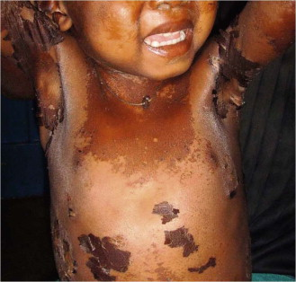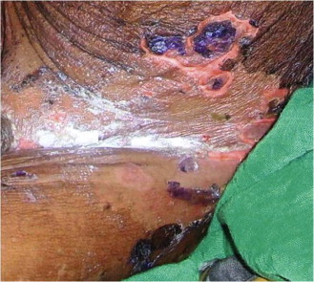
Citation: Rothe, Camilla. Clinical Cases In Tropical Medicine. [Place of publication not identified]: Saunders Ltd., 2014.

Ped8: Tetralogy of Fallot (Congenital Heart Disease)

HISTORY
The patient Ms …, 12-year-old, student, normotensive, nondiabetic, nonsmoker, presented with
breathlessness since her childhood. Her breathlessness was less marked in earlier stage, only felt
during moderate to severe activity. But for the last few months, it is progressively increasing, even during mild exertion. There is no seasonal variation to this breathlessness and it is not associated with exposure to dust, pollen or fume. There is no history suggestive of paroxysmal nocturnal dyspnea or orthopnea.

The patient also noticed bluish discoloration of skin, finger nail, toes and lips for the last … months, which is more marked during exercise and less by taking squatting position. She also experiences diffuse chest pain, usually following any activity or after eating, which radiates to left shoulder and subsides after taking rest. She also complains of palpitation, weakness and occasional dry cough. Her bowel and bladder habits are normal. Her mother mentioned that the patient used to become bluish and breathless while feeding or crying during the first few years of life. There is no history of such illness in her family.

Citation?

